AI ASSISTED CODING
ASSIGNMENT - 18.3
NAME: K.Hemanth Kumar
HL-NO: 2303A52320
BATCH: 45
Lab 18.3:
Task-1:
import json
from typing import Optional, Dict, Any

class PublicTransportFareAPI:
"""Retrieve public transport fare details between two stations."""
def __init__(self):
self.timeout = 10
def validate_station(self, station: str) -> bool:
if not station or not isinstance(station, str):
return False
if len(station.strip()) < 2:
return False
return True
def get_fare_details(self, source: str, destination: str) -> Optional[Dict[str, Any]]:
"""Simulated API (mock data)"""
# Validation
if not self.validate_station(source):
print("❌ Error: Invalid source station.")
return None
if not self.validate_station(destination):
print("❌ Error: Invalid destination station.")
return None
if source.lower() == destination.lower():
print("❌ Error: Source and destination cannot be same.")
return None
try:
# 🔥 MOCK DATABASE (simulate API)
routes = {
("warangal", "hyderabad"): {
"distance": 150,
"fare": 250,
"duration": 180,
"vehicle_type": "Bus"
},
("hyderabad", "warangal"): {
"distance": 150,
"fare": 250,
"duration": 180,
"vehicle_type": "Bus"
},
("delhi", "mumbai"): {
"distance": 1400,
"fare": 1200,
"duration": 1440,
"vehicle_type": "Train"
}
}
key = (source.lower(), destination.lower())
if key not in routes:
print("❌ Route not available in system.")
return None
data = {
"source": source.title(),
"destination": destination.title(),
**routes[key]
}
return data
except Exception as e:
print(f"❌ Unexpected error: {str(e)}")
return None
def display_fare_details(self, fare_data: Dict[str, Any]) -> None:
if not fare_data:
return
print("\n" + "=" * 50)
print("🚌 FARE DETAILS")
print("=" * 50)
print(f"Source: {fare_data['source']}")
print(f"Destination: {fare_data['destination']}")
print(f"Distance: {fare_data['distance']} km")
print(f"Base Fare: ₹{fare_data['fare']}")
print(f"Duration: {fare_data['duration']} mins")
print(f"Vehicle Type: {fare_data['vehicle_type']}")
print("=" * 50 + "\n")
def main():
api = PublicTransportFareAPI()
print("🚌 Public Transport Fare Finder\n")
source = input("Enter source station: ").strip()
destination = input("Enter destination station: ").strip()
fare_details = api.get_fare_details(source, destination)
if fare_details:
api.display_fare_details(fare_details)
else:
print("\n⚠️ Unable to retrieve fare details. Please try again.")
if __name__ == "__main__":
main()

Output:

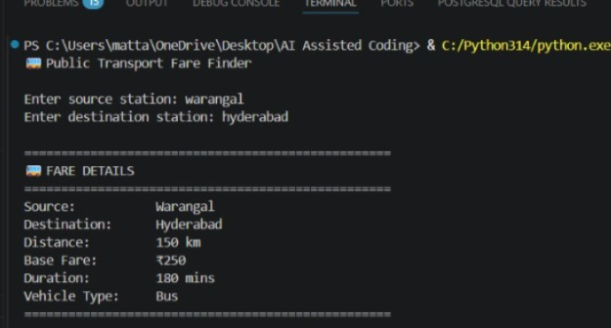

Task-2:
import requests
import sys
from datetime import datetime

class CurrencyConverter:
def __init__(self):
self.api_url = "https://api.exchangerate-api.com/v4/latest"
self.target_currencies = ["USD", "EUR", "GBP"]
self.timeout = 5
def validate_amount(self, amount):
try:
amount = float(amount)
if amount <= 0:
raise ValueError("Amount must be greater than 0")
return amount
except ValueError as e:
raise ValueError(f"Invalid amount: {e}")
def fetch_exchange_rates(self):
"""Fetch exchange rates OR use fallback"""
try:
response = requests.get(
f"{self.api_url}/INR",
timeout=self.timeout
)
response.raise_for_status()
return response.json()
except Exception:
# 🔥 FALLBACK DATA (IMPORTANT FOR EXAM)
print("⚠️ API failed. Using offline rates...\n")
return {
"rates": {
"USD": 0.012,
"EUR": 0.011,
"GBP": 0.0095
}
}
def convert_currency(self, amount, rates):
conversions = []
for currency in self.target_currencies:
if currency in rates["rates"]:
rate = rates["rates"][currency]
converted = amount * rate
conversions.append({
"From": "INR",
"To": currency,
"Amount": f"₹{amount:.2f}",
"Converted": f"{converted:.2f} {currency}",
"Rate": f"1 INR = {rate:.4f} {currency}"
})
return conversions
def display_results(self, conversions):
if not conversions:
print("No conversions available.")
return
print("\n" + "=" * 60)
print(f"💱 Currency Conversion Report")
print(f"🕒 {datetime.now().strftime('%Y-%m-%d %H:%M:%S')}")
print("=" * 60)
for conv in conversions:
print(f"{conv['Amount']} → {conv['Converted']}")
print(f"{conv['Rate']}")
print("-" * 60)
def run(self):
try:
amount_input = input("Enter amount in INR: ").strip()
amount = self.validate_amount(amount_input)
print("\nFetching exchange rates...")
rates = self.fetch_exchange_rates()
conversions = self.convert_currency(amount, rates)
self.display_results(conversions)
except ValueError as ve:
print(f"❌ Validation Error: {ve}")
sys.exit(1)
except Exception as e:
print(f"❌ Error: {e}")
sys.exit(1)
if __name__ == "__main__":
converter = CurrencyConverter()
converter.run()

Output:

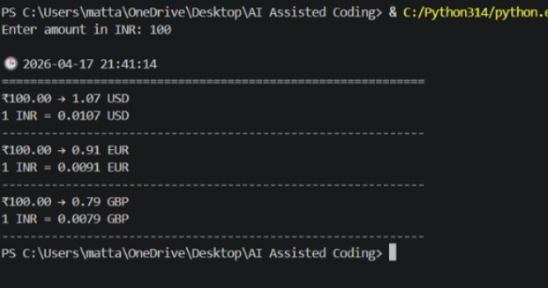

Task-3:
import requests
import json

try:
response = requests.get("https://jsonplaceholder.typicode.com/posts/1")
if response.status_code == 200:
data = response.json()
print("\nData received:")
print("=" * 50)
# Pretty formatted JSON
print(json.dumps(data, indent=4))
print("=" * 50)
else:
print("Error:", response.status_code)
except requests.exceptions.RequestException as e:
print("Request failed:", e)

Output:
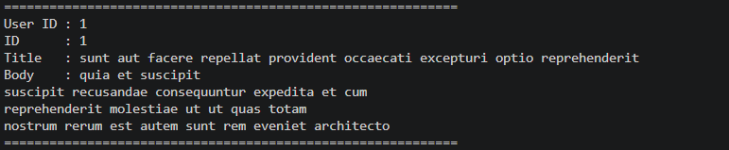

Task-4:
import requests
from typing import List, Dict
import time
from datetime import datetime

# Get a free API key from: https://newsapi.org/
API_KEY = "626ffaa3fbbb4003a199abfa159d9922"
BASE_URL = "https://newsapi.org/v2/top-headlines"
VALID_CATEGORIES = ["sports", "technology", "health"]
MAX_RETRIES = 3
RETRY_DELAY = 2
def fetch_headlines(category: str, retries: int = 0) -> List[Dict]:
"""
Fetch top 5 headlines for a given category with retry mechanism.
Args:
category: News category
retries: Retry attempt count
Returns:
List of news articles
"""
if category.lower() not in VALID_CATEGORIES:
raise ValueError(f"Choose from: {', '.join(VALID_CATEGORIES)}")
params = {
"category": category.lower(),
"country": "us",
"apiKey": API_KEY,
"pageSize": 5
}
try:
response = requests.get(BASE_URL, params=params, timeout=10)
response.raise_for_status()
data = response.json()
if data["status"] != "ok":
raise Exception(data.get("message", "Unknown error"))
return data["articles"]
except Exception as e:
if retries < MAX_RETRIES:
print(f"⚠ Error: {e}")
print(f"Retrying in {RETRY_DELAY} sec...\n")
time.sleep(RETRY_DELAY)
return fetch_headlines(category, retries + 1)
else:
raise Exception("Failed after retries")
def display_headlines(category: str) -> None:
"""
Display formatted headlines.
Args:
category: News category
"""
print("\n🕒", datetime.now().strftime("%Y-%m-%d %H:%M:%S"))
print("=" * 70)
print(f"📰 TOP 5 {category.upper()} HEADLINES")
print("=" * 70)
articles = fetch_headlines(category)
for i, article in enumerate(articles, 1):
title = article.get("title", "N/A")
source = article.get("source", {}).get("name", "N/A")
url = article.get("url", "#")
print(f"{i}. {title}")
print(f" Source : {source}")
print(f" Link : {url}")
print("-" * 70)
def main() -> None:
"""Main program.""
print("=" * 70)
print(" NEWS AGGREGATOR")
print("=" * 70)
print("Available Categories:", ", ".join(VALID_CATEGORIES))
while True:
category = input("\nEnter category (or quit): ").strip().lower()
if category == "quit":
print("\nGoodbye 👋")
break
try:
display_headlines(category)
except ValueError as e:
print("❌", e)
except Exception as e:
print("❌", e)
if __name__ == "__main__":
main()

Output:
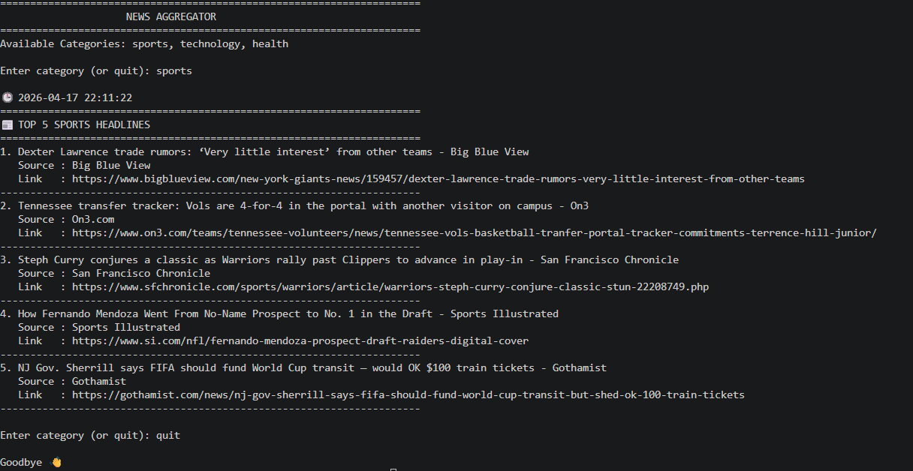

Task-5:
import requests
import time
from typing import Dict, Optional
from datetime import datetime

# Using disease.sh API (free, no authentication required)
BASE_URL = "https://disease.sh/v3/covid-19/countries"
def fetch_covid_data(country_name: str, max_retries: int = 3) -> Optional[Dict]:
"""
Fetch COVID-19 statistics for a specific country.
Args:
country_name: Name of the country
max_retries: Maximum retry attempts
Returns:
Dictionary with COVID stats or None
"""
for attempt in range(max_retries):
try:
response = requests.get(f"{BASE_URL}/{country_name}", timeout=10)
if response.status_code == 429:
wait_time = int(response.headers.get("Retry-After", 60))
print(f"⚠ Rate limit exceeded. Waiting {wait_time}s...")
time.sleep(wait_time)
continue
if response.status_code == 404:
print(f"❌ Country '{country_name}' not found.")
return None
response.raise_for_status()
return response.json()
except requests.exceptions.Timeout:
print(f"⚠ Timeout (Attempt {attempt+1}/{max_retries})")
time.sleep(2 ** attempt)
except requests.exceptions.ConnectionError:
print(f"⚠ Connection Error (Attempt {attempt+1}/{max_retries})")
time.sleep(2 ** attempt)
except requests.exceptions.RequestException as e:
print("❌ Error:", e)
return None
print("❌ Failed after maximum retries.")
return None
def display_covid_stats(data: Dict) -> None:
"""Display COVID data in formatted style."""
print("\n🕒", datetime.now().strftime("%Y-%m-%d %H:%M:%S"))
print("=" * 60)
print(f" COVID-19 STATISTICS FOR {data['country'].upper()}")
print("=" * 60)
print(f"Total Confirmed Cases : {data['cases']:,}")
print(f"Total Deaths : {data['deaths']:,}")
print(f"Total Recovered : {data['recovered']:,}")
print(f"Active Cases : {data['active']:,}")
print(f"Cases per Million : {data['casesPerOneMillion']:,}")
print(f"Deaths per Million : {data['deathsPerOneMillion']:,}")
print("=" * 60)
def main():
"""Main program."""
print("=" * 60)
print(" COVID-19 STATISTICS FETCHER")
print("=" * 60)
while True:
country = input("\nEnter country name (or 'exit'): ").strip()
if country.lower() == "exit":
print("\nGoodbye 👋")
break
if not country:
print("Please enter a valid country name.")
continue
print("\nFetching data...")
data = fetch_covid_data(country)
if data:
display_covid_stats(data)
else:
print("Could not fetch data.\n")
if __name__ == "__main__":
main()

Output:
